NEW PULL TICKET TO TRANSFER MATERIAL TO MACHINE FOR PRODUCTION:

This modification provides the ability to generate a PICK TICKET of material locations for the forklift operator to retrieve and delivery to a specific machine for production.
The pick ticket will list the warehouse and bin location of required materials such as board, corrugated cases, wax, window film, etc to deliver to the production machine that requires the material. For example, board may be delivered to a slitter, guillotine, sheeter or directly to a press, whereas corrugated cases may be delivered to a gluer. The pick ticket simply shows what machine to delivery the material and the material specific warehouse and bin locations where the material can be found.

The STEPS are SIMPLE:
- The user selects a material from the material folder tab of the job file.
- Once the material is highlighted, the new “XFER” button is clicked.
- The user selects a machine and confirms or changes the Pull Quantity.

Please note, the XFER button generates a pop-up screen where the MRP material required for the job is displayed as the “ PULL Quantity, which may be increased or decreased for the forklift operator to PULL and then selects the delivery Machine such as the Flexo 1”below.

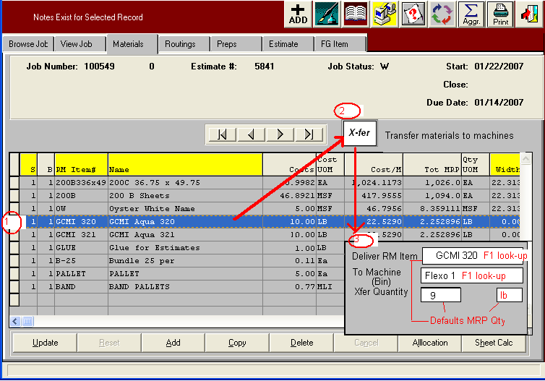

The output report would be a “pick list” for materials to be transferred to a bin named “Flexo 1”. This printed report would be carried into the plant and the user would use it to scan tags with the Sharp Shooter raw material transfer option. The machine that the goods are transferred to would be set up as a bin and a Sharp Shooter scan will transfer the material to the “machine bin”.

